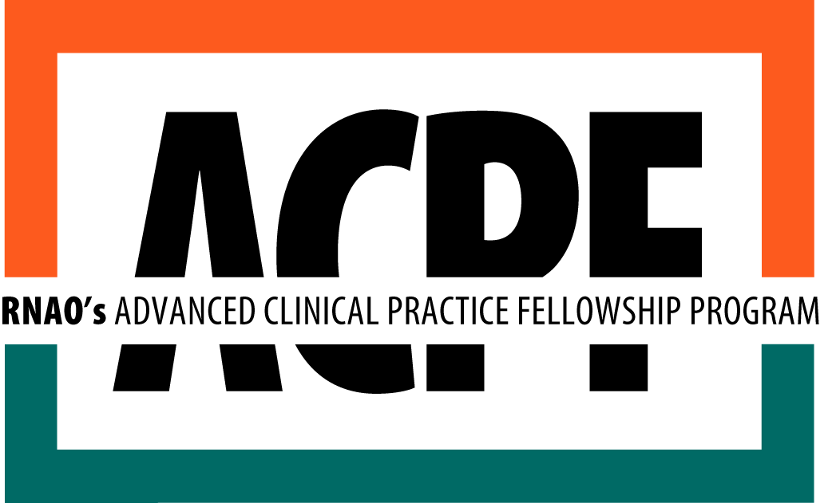

Proposal Application Template
2020 - 2021

Application Instructions

- Before You Apply:
- Plan to apply early! See application deadlines on rnao.ca/bpg/get-involved/acpf
- This information is used by RNAO to prepare for the Review Process; it is not binding and can be modified or withdrawn at any time.
- To notify RNAO of your intention to submit a proposal, please visit https://myrnao.ca/ACPFIntentToSubmit

- Complete & Submit Your Application:
- Please review the official Request for Proposal (RFP) document for program information, application instructions, and evaluation criteria.
- Submit your application online on http://m.sgizmoca.com/s3/ACPF-Application. You may complete your responses in this template first but must submit your final application online.
- Emailed proposals will NOT be accepted.

Application Components
- Applicant's Profile
- Fellowship Details
- Abstract
- Establishing the Need for the Fellowship
- Organizational Support
- Mentoring Support
- Learning Plan
- Proposed Budget
Supporting Documents
- Applicant’s Resume/CV
- Letter of Support from the applicant’s direct manager*
- Letter of Support from the applicant’s senior manager*
- Letter of Support from the Primary Mentor*
- Resume/CV for primary mentor

*Note: if an individual is fulfilling more than one role (i.e. direct manager and primary mentor, or Applicant’s senior manager and primary mentor’s manager), one letter may be submitted that addresses the requirements for both roles.

- After You Apply:
- All applicants will receive notification by email that their proposal has been received no later than one business day following the submission deadline. If you do not receive notification, contact Erica D’Souza at edsouza@rnao.ca.

Applicant's Profile

First Name:

Last Name:

Credentials:

Email:

Mailing Address:

Registration number with the College of Nurses of Ontario (CNO):

Is your sponsoring organization an RNAO Best Practice Spotlight Organization

- Yes
- No

Are you an RNAO Member?

- Yes
- No

Please check your highest level of education:

- Diploma
- Baccalaureate degree
- Masters degree
- PhD

Please check your employment status at your Sponsor Organization
- Full-time
- Part-time
- Casual

Please check the number of years’ of experience you have in Nursing:

- 1-2 years
- 3-5 years
- 6-10 years
- 11-15 years
- 16-25 years
- >25 years

Please indicate which of the following speciality areas will apply to your fellowship. Check as many as apply:

- Antenatal / Post-partum
- Cardiac Care
- Critical Care
- Diabetes
- Dialysis
- Emergency/Trauma
- Gerontology
- Health Promotion
- Infection Control
- Knowledge transfer / Guideline implementation
- Medical Surgical
- Neonatal
- Neurology
- Oncology
- Operating Room
- Paediatrics
- Pain
- Palliative Care
- Psychiatric/Mental Health
- Rehabilitation
- Wound Care
- Other:

Please indicate which one of the following categories best applies to your Sponsor Organization:

- Ambulatory Care
- Acute Care Hospital
- CHC/Primary Care
- Complex Continuing Care
- Long-Term Care
- Psychiatric Hospital / Mental Health
- Public Health
- Rehabilitation
- Home Care
- Other:

How did you first learn about the Advanced Clinical/Practice Fellowships? (check only one)

- RNAO Website
- RN Journal
- Word of mouth
- Posting in Organization
- Newsletter (organization/group title)_________________________
- Other (please specify):

Please upload an updated CV or resume:

Fellowship Details

Fellowship Stream:

- Clinical
- Best Practice Guideline Implementation (List relevant BPG(s))
- Leadership (Select Education, Policy, Research, or Management/Administration)

Fellowship Title:

Fellowship Start Date:
Fellowship End Date:

Senior Manager:

First Name:
Credentials:
Last Name:
Email:

Mailing Address:

Direct Manager:

First Name:
Credentials:
Last Name:
Email:

Mailing Address:

Primary Mentor:

First Name:
Credentials:
Last Name:
Email:

Organization:
Position:

Mailing Address:

Mentoring Team Members (if applicable):

First Name:
Credentials:
Last Name:
Email:

Organization:
Position:

Abstract

Provide an overview of the proposed fellowship project, including a summary of the following (500 words max.):

- Overall Learning Goal (skills, knowledge, and expertise you will gain through this experience)

- Organizational Context & Participants Involved - Describe the practice setting including the organization, specific unit, site, or location, as well as the fellowship participants; including distinct roles and responsibilities.

- Need for the Fellowship - Clearly identify the need or gap in service at the sponsor organization and why this project has been chosen as an opportunity for the applicant to develop their learning. Include literature, statistical data, and references from the sponsoring organization or external sources as appropriate.

- Clear and Measurable Outcomes - Identify clear, measurable and appropriate outcomes of the proposed fellowship with consideration given to the potential improvements on patient/client outcomes.

Establishing the Need for the Fellowship
- Describe the specific knowledge, skills and expertise you hope to develop through this fellowship. (350 words max.)

- Describe the link between the knowledge you hope to develop and your current role/practice. How will the knowledge gained and fellowship activities enhance your nursing practice? (350 words max.)

- Identify and describe the patient/client population to be affected by this fellowship.

- Complete the table below indicating the anticipated short term/long term outcomes of the fellowship and how they will impact the identified stakeholders. Identify a minimum of 2 long -term and 2 short-term outcomes.
Note: Potential impacts on the applicant’s role/practice can include (but are not limited to): enabling the applicant to better meet client/patient and/or community needs; be a resource or leader among colleagues; better address identified gap in service; personally impact organizational systems, tools, etc.
Stakeholders | Short-Term Outcomes (Immediate) | Anticipated Long-Term Outcomes  (1+ year)
Patient/Community

Colleagues

Organization

Organizational Support
- Describe how the proposed fellowship focus relates to any past, current or future initiatives/strategic priorities at your organization.

  - What previous work has been done in this area?
  - What future work is necessary/anticipated in this area?

- How have you engaged your manager(s) in identifying and defining the fellowship focus in the development of this proposal?
Note: Manager involvement can include (but is not limited to): discussions, meetings, facilitating communication and/or contact between potential mentors or other fellowship participants, providing support and/or guidance related to the need for the fellowship, assistance in gathering information for inclusion in the proposal, facilitating participation in activities taking place in the practice setting or within the organization.

- How will you keep your manager and/or team updated on your learnings throughout the fellowship?

- How will your organization support you in sustaining your knowledge and skills post fellowship?
Note: Sustainability strategies can include: opportunities for linking fellowship learnings and outcomes to other initiatives at the organization; collaborative initiatives or other measures; integration of the applicant into committees, projects or similar; integration of new responsibilities or roles into the applicant's practice, or other measures as appropriate.

- Will this fellowship require an ethics review? (Yes/No)

Note: Investigate and determine the process at your sponsor organization for determining Ethics Approval Requirements, and identify whether you will need to go through that process. You do not need to complete the ethics approval process before submission however you must determine whether or not you will need to do so if accepted, and what impact it will have on your fellowship activities and timeline.

- If an ethics review is required, describe the process for attaining approval.

- Attach two letters of support from the sponsoring organization:

Note: if an individual is fulfilling more than one role (i.e. direct manager and primary mentor, or Applicant’s senior manager and primary mentor’s manager, etc.), one letter may be submitted that addresses the requirements for both roles.

- The Senior Manager is the person responsible for providing strategic direction to the fellow’s practice area and has signing authority for the organization. This letter should provide detailed information regarding the following:

- Support for the applicant and the learning need/goal
- The ethics approval requirements for the organization and indication of whether or not ethics approval will be required for any fellowship activities.
- How the organization plans on sustaining the outcomes and impact of the fellowship after completion.

- The Direct Manager is the person responsible for supervising the applicant's regular practice and activities. This letter should provide detailed information regarding the following:

- Support for the applicant to be released from regular activities in order to facilitate work on the fellowship project.
- Support for the applicant and the learning need/goal
- The fellowship project activities and outcomes to be achieved through the fellowship
- How the organization will support the applicant in applying and disseminating the newly acquired knowledge

Mentoring Supports

- Please complete the chart below for the primary mentor and each member of the mentoring team, if applicable.

Name, credentials | Title and place of employment | Expertise and Role of Mentor | Mentoring Engagement Strategies
[Insert primary mentor’s name here]
[Insert name of one member of mentoring team]

[Add rows if necessary]

- Please attach a letter of support from the primary mentor detailing their support for involvement in this fellowship. This letter should provide detailed information regarding the following:

- The role of the primary mentor as described throughout the proposal.
- Support for the applicant, the learning need/goal, the fellowship project activities and outcomes to be achieved through the fellowship.
- The evaluation strategies identified and the plan for communication and engagement.
- A clear statement identifying that the primary mentor’s manager/supervisor is aware and supports the involvement of the primary mentor in this fellowship experience.

Note: If using a mentoring team, only the primary mentor must provide a letter of support.

3. Please attach a copy of the Primary Mentor's CV or resume.

Learning Plan

Overall Goal for Learning:
Identify the skills and/or knowledge that you hope to develop through this fellowship. The goal should reflect a focus on the applicant’s learning rather than the fellowship project or organizational goals, and be identical to the goal provided in the abstract.
SMART Learning Objectives  (Minimum of 3 Maximum of 5) | Activity | Contributor(s) & Communication Strategies  (as applicable) | Timeline  (Week # - Week #) | Evaluation Criteria for Success | Progress/ Status
Learning objectives should be focused on the learning needs of the applicant.  What are the specific skills or knowledge you intend to learn in order to achieve your learning goal?  Objectives should be specific, measurable, attainable, realistic and timely (SMART). | These are the activities that you will engage in to meet each objective. | Identify who will be involved in supporting each activity and how you will communicate with them? | Start Date - End Date | How do you know this objective was achieved successfully?  Identify the evaluation criteria used in determining success. | This section should be updated throughout the fellowship and will be submitted as part of the final report.
Note: You may refer to the Learning Plan Checklist and video workshop on Developing the Learning Plan to ensure you have met all of the requirements.

Proposed Budget

The fellowship budget must cover all costs associated with the fellowship, and capture the full contribution of all parties to the fellowship.

- All costs related to support at the Sponsor Organization must be reflected in the Sponsor Organization Contribution column alone.
- All in-kind costs must be assigned a dollar value, but clearly marked as 'IN-KIND'.
- Ensure a brief description is provided regarding each item.

Item No. | Budget Items | Total Anticipated Cost  (Total = Column 2 + Column3) | RNAO Contribution  ($15,000 max.) | Sponsor Organization Contribution ($5000 min.) | Description of Costs
1. | Applicant’s Salary
2. | Applicant’s Benefits
3. | Management support (time, evaluation, etc.)
4. | Administrative Support
5. | Communication
6. | Library Services
7. | Printing costs (handouts, resource books, etc.)
8. | Training for replacement staff
9. | Conference Attendance
10. | Dissemination of newly acquired knowledge (e.g.: in-services/ educational materials, etc.)
11. | Education
12. | Parking
13 | Travel (air, bus, train, mileage, etc.)
14. | Accommodations
15. | Meals
16. | Miscellaneous (provide details)
 | TOTAL:

