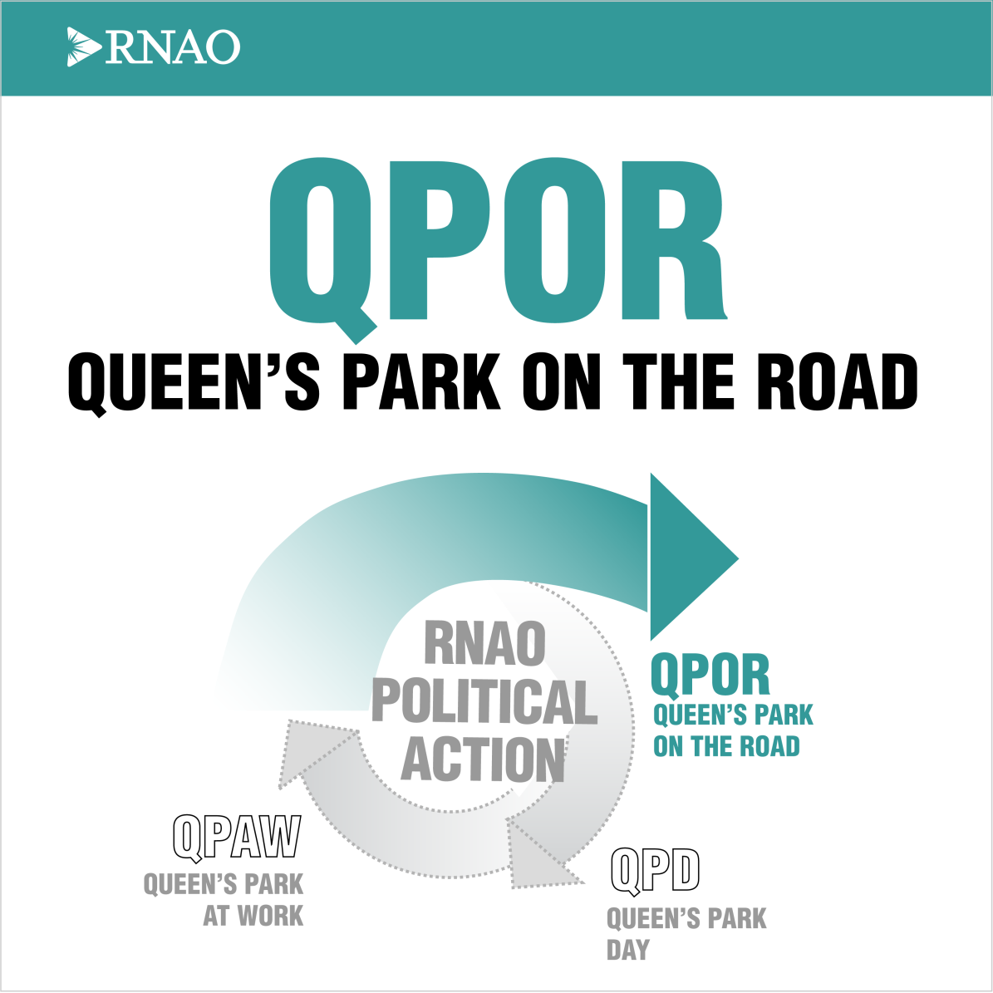
RNAO’s Queen’s Park on the Road
2021 Member Toolkit
Speaking out for nursing. Speaking out for health.
Connecting with Your MPP
1. Notify your policy and political action executive network (PPAN) officer of your interest in participating in QPOR. To find your PPAN officer, visit the RNAO Chapter and Region website. Contact Ann-Marie Morris, amorris@RNAO.ca, should you not be able to locate your PPAN officer.
2. To find your MPP and find contact information, please click here
3. Click on the MPP’s name on the following page – this redirects to the Ontario Legislative Assembly website
4. Record the contact information for the MPP
5. Use the MPP meeting invitation script/email provided, Appendix C, to connect with the MPP by telephone or email. Follow-up if necessary.
Preparing for Your QPOR MPP Meeting
♦ Notify, or assign someone to notify, RNAO home office (Ann-Marie Morris, amorris@RNAO.ca) to book your meeting on Zoom and receive your Zoom account information.
♦ Read and familiarize yourself with RNAO’s priority issues fact sheets and political action bulletins so that you are confident presenting the information to your MPP.
♦ Connect with other members of your Region/Chapter to identify additional participants. If applicable, determine roles (eg. Chair, Recorder).
♦ Ensure you book your meeting using the Zoom account of RNAO’s Policy Department.
Familiarize yourself with Zoom before conducting the meeting. You will need to know how to, for example, share your screen, how the raise hand feature works, or how to mute or unmute participants. If you need assistance with this or would like to schedule a practice session, please Ann-Marie Morris, amorris@RNAO.ca.
♦ Ensure you have a telephone number for the MPPs and other member participants in the event of an emergency
♦ Before you conclude your Zoom meeting, request to have a photo taken for social media as well as our e-newsletter In The Loop and RNJ.
♦ Post photos with the MPP to social media (remember to tag RNAO) and send them to Ann-Marie Morris (amorris@RNAO.ca).
♦ Ensure you arrange a debrief with other member participants after the meeting to discuss your overall impression of the event. Please use the recorder sheet, Appendix A, to capture what was said during the meeting. This document should then be submitted to amorris@RNAO.ca at home office once completed.
♦ Remember to have fun!
Roles and Responsibilities
It is helpful to attend your meeting with another member or members of your RNAO Region/Chapter. It is especially important to assign the role of Chair to ensure that you have the opportunity to present the materials in an organized fashion. Normally, for an in-person meeting, it would be helpful to assign someone to record or take notes of the conversation and commitments. However, we are asking you to record your Zoom call.
The role of the Chair is to:
- Oversee and manage the meeting. Ensure the meeting starts on time.
- Introduce the group (name, role with RNAO if any—Board, Chapter, Interest group member, student and/or constituent of the MPP)
- Keep the discussion on track.
- Present RNAO’s “Asks” and letter templates for submission to the appropriate individual, appendix D, E & F.
- Thank the MPP and request permission to take and post group photo
- Invite the MPP to participate in Annual Queen’s Park Day in February 24, 2022
Dos and Don’ts for QPOR Meetings
Dos:
• Do a little research on your MPP beforehand to see if there is a way to connect more personally. They live in your community. What do you have in common? Did you go to the same high school? Do your kids play sports together? This will set the tone for a focused but more relaxed conversation.
• Be punctual – start and end the meeting at the appointed time
• After the meeting has begun, be sure to stay focused. Don’t let the MPP find a way to avoid what they may find to be a difficult conversation.
• Tell a story. As nurses you have compelling stories to tell. And certainly on these two issues, nearly everyone has a story to tell. Use your stories. Use personal examples from your work or community to support the key messages RNAO is trying to deliver in the meeting. Remember – politicians value and appreciate your knowledge and experience as a nurse. Be confident in your ability to use personal and work narratives to make your point about nursing and health care.
• Be sure to give your MPP time to express their view(s). Listen, understand and respond to what they are saying. We already know what we think. We want to know what they think!
• Be sure to ask the MPP whether they support your position and, if they do, be sure to turn that support into action!
• Raise the “Asks” found in the toolkit and present the MPP with the template letters developed by home office for submission to the appropriate politician. This will ensure the appropriate follow-up action is taken.
• Pay attention to and be polite to staff for three reasons: a) staff often control access to the MPP and their time; b) staff often need to understand the policy issues and nuances in greater detail than the MPP; and, c) just because!
Don’ts:
• Be late for the meeting—even if the MPP does not start on time.
• Speak for so long that there is no time left for questions.
• Speak negatively about the previous or current government.
• Contradict RNAO’s positions.
• Say, in response to a question, “I don’t know.” Instead, tell the MPP, “I will get back to you with details as soon as possible.”
• Refer to your own political party membership (if any). RNAO is a non-partisan organization that works with MPPs from all political parties.

Appendix A – Meeting Minutes Template
Name of MPP:
Date:
Name/title of any MPP staff in meeting:
Name of recorder:
Names of other RNAO members in meeting:
Response to Issue #1:
Are they sending a letter and when?
Response to Issue #2:
Are they sending a letter and when?
Response to Issue #3:

Are they sending a letter and when?

Complete this form and send to amorris@RNAO.ca along with any photos taken. Thank you!

Appendix B - Sample agenda for QPOR meeting with MPP
1:00 pm Introduction of RNAO members | Thank MPP for meeting  Introduction of RNAO members attending  Introduce RNAO to the MPP using “Intro Fact Sheet”  Thank MPP for past support of RNAO events if applicable | Chair
1:05 pm | Highlight the priority issues that will be addressed  - RN human resources crisis | Chair
1:10 pm | Reinforcement of information and recommendations found within political action bulletins  Specific/personal examples of workplace/community | All RNAO members
1:45 pm | Ask for their support.  Translate support to action:  - Present “Ask” letter templates to MPP  - Get a commitment from the MPP to send a letter to the Minister | Chair
1:55 pm | Conclusion – thank MPP for meeting  Confirm follow-up details  Ask permission and take a screen shot of the group | Chair
2:00 pm | Debrief after the meeting has concluded, ensuring that the MPP and their staff are not present, to document observations of MPP responses | Chair

Appendix C – MPP Meeting Invitation Script/Email
(MPP)
(Riding)
(Address)
(Email)
[insert date]

Dear (MPP),
I am a constituent and a/an (RN/NP/nursing student) concerned about health care in Ontario. I am also the [identify your position with RNAO or indicate that you are a member] of the Registered Nurses’ Association of Ontario (RNAO). RNAO is the professional association representing more than 47,000 registered nurses, nurse practitioners, and nursing students in Ontario.
Annually for the last eight years, RNAO members visit the MPP in their riding to discuss issues and opportunities to enhance nursing, health, and health-care delivery. We call this event Queen’s Park on the Road (QPOR). This year, I am hoping you will join me on Zoom for a virtual meeting to discuss RNAO’s priority issue - the RN Human Resource Crisis. RNAO members are committed to political engagement and we value the positive working relationships we have with MPPs across the province. QPOR is an important initiative to foster these relationships.
Would you please set aside an hour of your time at your convenience to meet with me and a few colleagues who live in your riding? We are aiming for the week of November 8th - 12th, but I am happy to work within your schedule.
Could you please let me know when you’re available to meet by contacting me via email at XXXX ? We are keen to share our experiences in the health system with you in the hopes of positively influencing public policy. In anticipation of our meeting, I thank you very much in advance.
Warm regards,
(name)
(email)
(optional telephone)

CC: Ann-Marie Morris, RNAO, amorris@rnao.ca

Appendix D - Letter Template for MPPs – Repeal Bill 124

Hon. Doug Ford, Premier of Ontario
Premier's Office
Room 281
Legislative Building, Queen's Park
Toronto, ON M7A 1A1

[insert date]

Re: Repeal Bill 124

Dear Premier Ford,

Bill 124 caps compensation for RNs at just one per cent. In real terms, this means RN incomes are not keeping up with the cost of living. Bill 124 demonstrates a profound lack of respect for those professionals we have called heroes during the COVID-19 pandemic. We cannot retain or recruit nurses without Bill 124 being repealed.
Throughout the past 21 months of this pandemic, RNs have selflessly cared for citizens of Ontario while confronting fears for their own health and safety and that of their loved ones. They are exhausted and burnt out. RNs have left and are continuing to leave the profession. Bill 124 is largely to blame for this exodus.
The departure of RNs from the profession will lead to even longer wait times for already backlogged procedures and surgeries, compromising health and risking mortality for those who need a strong health system. The departure of RNs threatens the effective functioning of Ontario’s health system.
The health system depends on RNs. Yes, public officials have uttered words of appreciation. But meaningful and tangible signs of appreciation have been sparse. Premier, Bill 124 must be repealed.

[MPP]
[Name]
[Riding]
[Address

CC: Ann-Marie Morris, RNAO, amorris@rnao.ca

Timelines and Milestones
Activity/Action | Timeline/deadline
Notify your Chapter or Region’s PPAN officer you are interested in participating in QPOR | November
Contact MPP constituency office and confirm virtual meeting date | November
Notify RNAO home office that meeting is confirmed (email: Ann-Marie Morris, amorris@rnao.ca) | November
Visit https://rnao.ca/events/queens-park-on-the-road and continue to familiarize yourself with supporting materials:  - Priority issue fact sheet and political action bulletin  - MPP Ask letter templates  - QPOR 2021 Toolkit  Member participants should be familiar with all information and recommendations in advance of the MPP virtual meeting. | November  .
Confirm other member participants from within your Chapter/Region | November
Confirm virtual meeting with MPP’s constituency office | Two days prior to meeting
MPP Meetings  Note: be sure to ask permission to take a photo and share with RNAO for social or publication. | November to mid-December
Connect with home office and submit recording of the meeting as well as any photos that were taken | Following meeting
Thank you email and MPP Ask follow-up (if necessary) | January 2022 onwards

