Oral Care Community of Practice 2015/16
Oral Health Baseline Data Collection Tools
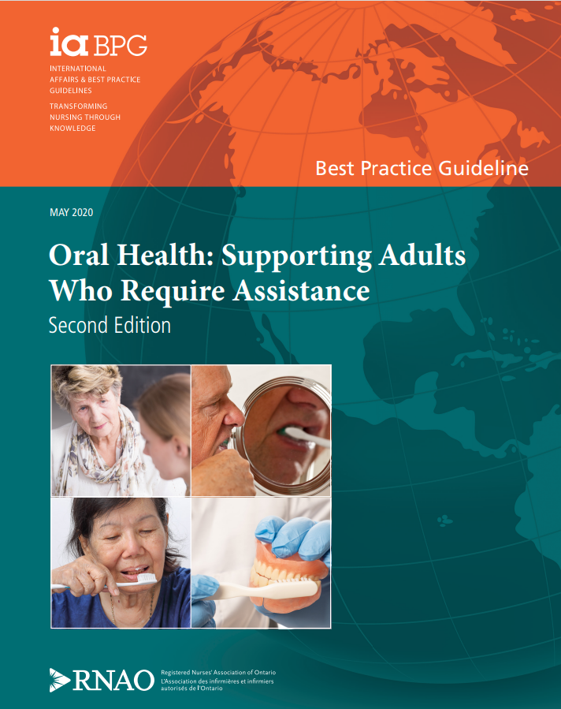

10/27/2015
Ibo MacDonald – LTC Best Practice Coordinator Champlain LHIN

The Purpose of the Oral Health Baseline Data Collection Booklet
The purpose of this booklet is to provide Oral Care Teams with the documents that they can use to capture oral health
baseline data. By capturing baseline oral health data your team can use this information to help establish priorities, to develop your oral care work plan, to assist with evaluating changes in oral care practices over time, and to create your homes’ oral care education plan.

- RAI-MDS data
- Electronic (POC) and/or flow sheet data
- Chart Audit
- Supply audit
- Baseline oral health assessment of some/all residents
- Oral Health Knowledge Survey for Staff
- Resident/family satisfaction questionnaire

Getting Started
First, bring together your Oral Care Team and review the various baseline data collection strategies (see box to the left). As a team determine which strategies you would find useful to use. Narrow down the strategies that will be used and decide who is responsible for data collection.
NOTE: The RAI-MDS data and Oral Health Knowledge Survey for Staff are two documents that are required by all participating LTCHs

Any feedback on these tools is appreciated – please send to ibo at imacdonald@rnao.ca

Contents
The Purpose of the Oral Health Baseline Data Collection Booklet 2
Getting Started 2
RAI-MDS Table 3
Oral Health Chart Audit Tool 4
Oral Care Supplies Audit Tool 5
Oral Health Knowledge Survey 6

RAI-MDS Table
Person completing: Date:

RAI-MDS | # of  residents
Section K
K1a Chewing problems
K1b Swallowing problems
K1c Mouth pain
K2c Complains about the taste of many foods
Section L
L1a Debris present in mouth prior to going to bed at night
L1b Has dentures or removable bridge
L1c Some or all natural teeth lost – does not have or does not use dentures or
partial plates
L1d Broken, loose, or carious teeth
L1e Inflamed gums, swollen or bleeding gums, oral abscesses, ulcers, or rashes
L1g Daily cleaning of teeth or dentures, or daily mouth care – by staff or resident
Other
E4e Resists care (*must identify if this is in relation to oral care)

Oral Health Chart Audit Tool
(√ all that apply) Person completing: Date:

# | Resident Room | Admission |  |  |  |  |  |  | Care Plan
# | Resident Room |  |  |  |  |  | Dentures
# | Resident Room | Oral Health Assessment tool completed | Resident oral health beliefs, preferences/ routines documented | Resident oral health dental history documented | Contract: external dental/oral care signed by resident/ SDM and in  chart | Registered staff documented admission oral health discussion | labeled and type of label documented | type(s) - full, partial etc. documented | Level of oral care / assistance described | Required oral care equipment described | Techniques/ strategies for resident with responsive behaviours described | Risk for aspiration identified and reflected in oral care plan
Total and convert to
%

Oral Care Supplies Audit Tool
(√ all that apply and make notes as required) Person completing: Date:
Supplies | Resident rm # | Resident rm # | Resident rm # | Resident rm # | Resident rm # | Resident rm # | Totals
Toothbrushes
Present
Labelled
Appearance –clean (not worn) | Notes: | Notes: | Notes: | Notes: | Notes: | Notes:
Dentures
Present
Labelled/legible
Condition -clean
Denture cup (DC)
DC labelled
DC clean
Denture brush (DB) present
DB labelled
DB condition - clean | Notes: | Notes: | Notes: | Notes: | Notes: | Notes:
Other oral care supplies
Toothpaste present
Toothpaste labelled
Mouth wash present
Mouth wash labelled
Cup for rinsing the mouth
Cup labelled
Cup clean
Lip moisturizer
Lip moisturizer labelled
Other:
Other labelled
Location of oral care supplies
In the right location
Where were supplies found

Oral Health Knowledge Survey
Please complete the table below using the "Oral Care Approaches" in the first "white" column. In column #2 (Yellow) - Rate your level of knowledge around the following oral care approaches. In Column #3 (Blue) - Indicate how often you use each oral care approach in your day-to-day practice
LTCH Name: Position (X): □ RN □ RPN □ PSW □ Other  Typical shift worked: □ Day □ Evening □ Night □ Varies  Oral Care Approaches | Rate your level of knowledge  - – No knowledge  - – Minimal knowledge  - – Average knowledge  - – Expert knowledge  - – Not part of my job | How often do you perform these approaches  - – Never  - – Rarely  - – Often  - - Always/daily  - – Not part of my job
1. Using a regular tooth brushing
2. Using an electric toothbrush
3. Using mouth wash
4. Using oral rinses (i.e. Nystatin, Chlorhexidine)
5. Using saliva substitutes
6. Cleaning the oral mucosa
7. Using a 4x4 gauze to clean the mouth
8. Cleaning dentures
9. Completing an oral health status assessment
10. Noticing subtle changes in oral health status
11. Assessing oral pain in a cognitively impaired resident
12. Assessing fit of dentures
13. Identifying problems with teeth (broken or loose)
14. Identifying residents who have dry mouth
15. Providing oral care to a resident with responsive behaviours
16. Providing palliative/end-of-life oral care to residents
17. Using the 2-toothbrush technique
18. Using techniques to encourage a resident to open their mouth
19. What is oral debris? (what things would you see in a residents mouth that would make you say that the resident has oral debris):
Part 2: Beliefs, attitudes and knowledge about oral health - Please place a check mark (√) to indicate your level of agreement with each statement.
Statement | 1- Strongly  agree | 2 - Agree | 3 – Neither | 4 - Disagree | 5 – Strongly  disagree
20. I believe oral hygiene is a high priority
21. I find the oral cavity difficult to clean
22. I believe that good oral care has a significant impact on residents’ health outcomes
23. I believe oral care is important at end of life
24. I am satisfied with my oral care practices for my residents
25. I need more information/education on oral care

