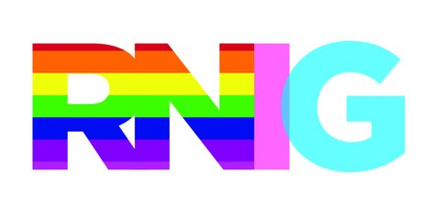

When Someone Comes Out to You as LGBT identified

Thank the person for having the courage to tell you.

Please keep in mind that an LGBT person cannot accurately predict your
reaction to their coming out to you. You have lived in a society that often teaches
intolerance of LGBT people. Therefore, by telling you, this person is putting a
large amount of trust in just a few words. At that one point, they have the
possibility of losing you as a friend or family member, so often times the decision
to first share that piece of their life is not one taken lightly. Do not judge the
person, if you have strong religious or other beliefs about LGBT identities keep
them to yourself. Ensure that you respect this person’s confidentiality and tell
them you still care about them, no matter what.

Understand that the person has not changed.

They are still the same person they have always been. You might be
uncomfortable or surprised by the news at first, but make an effort to understand
why you are surprised or uncomfortable. Also, this person may share things with
you related to this part of their life. Do not assume this person is coming on to
you or finds you attractive.

Ask Questions.

You can ask questions of the individuals, but understand that they might not have
all the answers. If you want to learn more, say so. It helps to admit to yourself out
loud that you are not an authority on the subject. Also, understand that it is not
this person’s job as an LGBT person to educate you fully; be prepared to do your
own research. You may want to keep the conversations going and provide a way
to contact the person in the future. This interaction lets the person answer your
questions at a pace that is their own.

Helpful Responses for Discussion Around LGBT Identity:

It’s okay if you are LGBT identified.
I can appreciate how difficult it must have been for you to tell me this.
If you are LGBT, what are the kinds of things that worry you most?
What kind of support do you think you need from me?
I may not have all the information, but I can find more for you?

Potentially Damaging Responses:

How do you know? Are you sure?
You’re too young to make a decision like that.
How can you know if you’ve never had sex with someone of the opposite
sex? It’s just a phase you are going through.
A lot of people experiment or fantasize; it doesn’t mean you are LGBT.
It’s fine that you told me, but you shouldn’t tell.
Maybe you just haven’t met the right person yet.

